

**MGM’s POLYTECHNIC, AURANGABAD**

**2020-2021**

Micro Project Report

On

**“Make at least one model on ideal gas process ”**

Submitted in partial fulfillment for ‘I’ Scheme second semester of

**Diploma in**

**MECHANICAL ENGINEERING**

**By**

**MOHAMMED SAAD SAYYED ( 1915010276 )**

Under the guidance of

**Prof. Nagre G.P**

(Lecturer in Mechanical Engineering)

***In Pursuit of Excellence***



[**Maharashtra State Board of Technical Education, Mumbai**](http://msbte.org.in/)

**(Autonomous) (ISO-9001-2008) (ISO/IEC 27001:2013)**



**Maharashtra State**

**Board of Technical Education, Mumbai**

**Certificate of Completion**

This is to certify that Mr./Ms. .. **DHAKNE RAMAKANT MAHENDRA , MOHAMMED SAAD SAYYED ,JADHAV SWARAJ MILIND** with Enrollment No **1915010275 , 1915010276 , 1915010277** has successfully completed his/her Micro-Project entitled **" Make at least one model on ideal gas process** " in the Course/Subject of " **Mechanical Engineering Materials** **[22343]** "in the second semester during his/her tenure of completing the Diploma programme in Mechanical Engineering From MGM's Polytechnic institute with institute code 1501**.**

**Prof. Nagre G.P Prof. Bhalekar B.D**

**Guide HOD**

Mechanical Engineering Mechanical Engineering

**Dr. B.M. Patil**

**Principal**

**INDEX**

|  |  |  |
| --- | --- | --- |
| **Sr. No.** | **Content** | **Page No.** |
| **Micro-Project Proposal (ANNEXURE-I)** | |  |
| 1.0 | Aims/Benefits of the Micro-Project |  |
| 2.0 | Course Outcomes Addressed |  |
| 3.0 | Proposed Methodology |  |
| 4.0 | Action Plan |  |
| 5.0 | Resources Required |  |
|  |  |  |
| **Micro-Project Report (ANNEXURE-II)** | |  |
| 1.0 | Rationale |  |
| 2.0 | Aims/Benefits of the Micro-Project |  |
| 3.0 | Course Outcomes Achieved |  |
| 4.0 | Literature Review |  |
| 5.0 | Actual Methodology Followed |  |
| 6.0 | Actual Resources Used |  |
| 7.0 | Outputs of the Micro-Projects |  |
| 8.0 | Skill Developed / Learning outcomes of this Micro-Project |  |
| 9.0 | Applications of this Micro-Project |  |

**Annexure – I**

**Micro-Project Proposal**

**Make at least one model on ideal gas process**

**1.0 Aims/Benefits of the Micro-Project**

a) Concept of ideal gases.

b) Working of model.

c) Application of ideal gas process.

d) Types of ideal gases

**2.0 Course Outcomes Addressed**

* Able to process design of model.
* Working of model
* Study of thermo flask
* We see different type of heat exchanger

**3.0 Proposed Methodology**

1. Firstly we have got our topic on micro project
2. We have discuss with the respected sir
3. They give some suggestion about the work
4. We also search the topic on Google for more details
5. Then we discuss the topic with the team member
6. After collecting all the data we collect all materials for the topic
7. We have buy product for model of thermo flask
8. We make the model and shown to the sir
9. After approval of the information we start typing report on the topic
10. We make the report and finalize the correction form the sir
11. After the all correction and details we submit the report to the respected sir

**4.0 Action Plan**

|  |  |  |  |  |
| --- | --- | --- | --- | --- |
| **S. No.** | **Details of activity** | **Planned Start date** | **Planned Finish date** | **Name of Responsible Team Members** |
|  | Finalization of Micro Project Team | 13th Oct 2020 | 14th Oct 2020 |  |
|  | Finalization of Topic | 16th Oct 2020 | 17th Oct 2020 |  |
|  | Literature Survey | 18th Oct 2020 | 19th Oct 2020 |  |
|  | Submission of Micro-Project Proposal (ANNEXURE-I) | 19th Oct 2020 | 20th Oct 2020 |  |
|  | Proposed Methodology | 21st Oct 2020 | 24th Oct 2020 |  |
|  | Collecting Resources Required (raw material) | 25th Oct 2020 | 27th Oct 2020 |  |
|  | Making of Prototype/Working Model | 28th Oct 2020 | 31st Oct 2020 |  |
|  | Submission of Micro-Project Report (ANNEXURE-II) | 1st Nov 2020 | 2nd Nov 2020 |  |
|  | Presentation via PPT to Institute | 3rd Nov 2020 | 5th Nov 2020 |  |

**5.0 Resources Required**

|  |  |  |  |
| --- | --- | --- | --- |
| **Name of Resource/material** | **Specifications** | **Qty.** | **Remarks** |
| Bottles | -body | 2 |  |
| Aluminum foil | Vacuumed | 1 |  |

**Name of Team Members with Roll No**

**1)** **DHAKNE RAMAKANT MAHENDRA (22113)**

**2) MOHAMMED SAAD SAYYED (22114)**

**3) JADHAV SWARAJ MILIND (22115)**

**Annexure – II**

**Micro-Project Report**

**Make at least one model on ideal gas process**

1. **Rationale**

A vacuum flask is usually used to insulate it's contents… I've used them for a multitude of things ranging from keeping my coffee warm, to keeping liquid nitrogen from evaporating.

The reason these types of flasks are so efficient has to do with their thermodynamic properties. To understand how a vacuum flask works, we need to know the basic properties of a vacuum. Air just like any other molecule is a conductor of heat.

Firstly, a “layer of vacuum” is created around the thermos, it's crucial that the chamber is depressurized*.

In [thermodynamics](https://en.wikipedia.org/wiki/Thermodynamics), an **isothermal process** is a type of [thermodynamic process](https://en.wikipedia.org/wiki/Thermodynamic_process) in which the [temperature](https://en.wikipedia.org/wiki/Temperature) of the [system](https://en.wikipedia.org/wiki/Thermodynamic_system) remains constant: Δ*T* = 0. This typically occurs when a system is in contact with an outside [thermal reservoir](https://en.wikipedia.org/wiki/Thermal_reservoir), and the change in the system will occur slowly enough to allow the system to continue to adjust to the temperature of the reservoir through [heat](https://en.wikipedia.org/wiki/Heat) exchange (see [quasi-equilibrium](https://en.wikipedia.org/wiki/Quasi-equilibrium)). In contrast, an [*adiabatic process*](https://en.wikipedia.org/wiki/Adiabatic_process) is where a system exchanges no [heat](https://en.wikipedia.org/wiki/Heat) with its [surroundings](https://en.wikipedia.org/wiki/Surroundings_(thermodynamics)) (*Q* = 0).

Simply, we can say that in [isothermal](https://en.wikipedia.org/wiki/Isothermal) process

* {\displaystyle T={\text{constant}}}{\displaystyle Q=0.}T = constant
* delta T de delta T = 0
* dtd ddt = 0

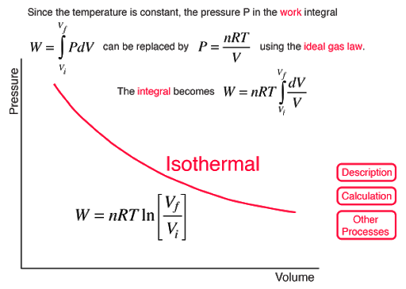

1. **Aims/Benefits of the Micro-Project:**

a) Concept of ideal gases.

b) Working of model.

c) Application of thermo flask

d) Types of thermo flask

**3.0 Course Outcomes Achieved**

* Able to process design of model.
* Working of model
* Study of thermo flask
* We see different type of heat exchanger

.

**4.0 Literature Review**

A **vacuum flask** (also known as a **Dewar flask**, **Dewar bottle** or **thermos**) is an [insulating](https://en.wikipedia.org/wiki/Thermal_insulation) storage vessel that greatly lengthens the time over which its contents remain hotter or cooler than the flask's surroundings. Invented by [Sir James Dewar](https://en.wikipedia.org/wiki/Sir_James_Dewar) in 1892, the vacuum flask consists of two [flasks](https://en.wiktionary.org/wiki/flask), placed one within the other and joined at the neck. The gap between the two flasks is partially evacuated of air, creating a near-[vacuum](https://en.wikipedia.org/wiki/Vacuum) which significantly reduces heat transfer by [conduction](https://en.wikipedia.org/wiki/Heat_conduction) or [convection](https://en.wikipedia.org/wiki/Convection).

Vacuum flasks are used domestically, to keep [beverages](https://en.wikipedia.org/wiki/Beverage) hot or cold for extended periods of time, and for many purposes in industry.

Isothermal processes are of special interest for ideal gases. This is a consequence of [Joule's second law](https://en.wikipedia.org/wiki/Joule_effect#Joule's_second_law) which states that the [internal energy](https://en.wikipedia.org/wiki/Internal_energy) of a fixed amount of an ideal gas depends only on its temperature.[[4]](https://en.wikipedia.org/wiki/Isothermal_process#cite_note-Klotz-4) Thus, in an isothermal process the internal energy of an ideal gas is constant. This is a result of the fact that in an ideal gas there are no [intermolecular forces](https://en.wikipedia.org/wiki/Intermolecular_forces).[[4]](https://en.wikipedia.org/wiki/Isothermal_process#cite_note-Klotz-4) Note that this is true only for ideal gases; the internal energy depends on pressure as well as on temperature for liquids, solids, and real gases.[5]

For the special case of a gas to which [Boyle's law](https://en.wikipedia.org/wiki/Boyle%27s_law)[[4]](https://en.wikipedia.org/wiki/Isothermal_process#cite_note-Klotz-4) applies, the product *pV* is a constant if the gas is kept at isothermal conditions. The value of the constant is *nRT*, where *n* is the number of moles of gas present and *R* is the [ideal gas constant](https://en.wikipedia.org/wiki/Ideal_gas_constant). In other words,

the [ideal gas law](https://en.wikipedia.org/wiki/Ideal_gas_law)  *pV* = *nRT* applies.[]](https://en.wikipedia.org/wiki/Isothermal_process#cite_note-Klotz-4) Therefore:

{\displaystyle p={nRT \over V}={{\text{constant}} \over V}}

holds. The family of curves generated by this equation is shown in the graph in Figure 1. Each curve is called an isotherm. Such graphs are termed [indicator diagrams](https://en.wikipedia.org/wiki/Indicator_diagram) and were first used by [James Watt](https://en.wikipedia.org/wiki/James_Watt) and others to monitor the efficiency of engines. The temperature corresponding to each curve in the figure increases from the lower left to the upper right

**5.0 Actual Methodology Followed**

1. Firstly we have got our topic on micro project
2. We have discuss with the respected sir
3. They give some suggestion about the work
4. We also search the topic on Google for more details
5. Then we discuss the topic with the team member
6. After collecting all the data we collect all materials for the topic
7. We have buy product for model of thermo flask
8. We make the model and shown to the sir
9. After approval of the information we start typing report on the topic
10. We make the report and finalize the correction form the sir
11. After the all correction and details we submit the report to the respected sir

**6.0 Actual Resources Used** (Mention the actual resources used)

|  |  |  |  |  |
| --- | --- | --- | --- | --- |
| **S. No.** | **Name of Resource/material** | **Specifications** | **Qty.** | **Remarks** |
|  | Microsoft Power Point |  | - |  |
|  | Google |  | - |  |

**7.0 Outputs of the Micro-Projects**

* Changes of state
* or phase
* changes of different liquids through the **process** of melting
* and evaporation

**8.0 Skill Developed / Learning outcomes of this Micro-Project**

* One of the **examples** of the industrial application of the **isothermal process** is the Carnot engine. ... A refrigerator works **isothermally**.

**9.0 Applications of this Micro-Project**

Isothermal process is one in which the temperature remains the same. There is a constant set of changes taking place in the mechanics of a refrigerator but the end result is that the temp inside remains constant. Heat energy is removed and transmitted to the surrounding environment (i.e. your kitchen). Another example is a heat pump. Heat is either removed from the home and dumped outside or heat is being brought in from the outside to warm the home. In either case the goal is to keep the home’s interior at the desired setting. Energy is expended to move heat from one place to another, so there are reactions taking place. But the net effect in the space we are measuring is zero.

It's used to keep cool things cool, and hot things hot. Such as hot coffee, or cold water. If you would like to know how it works, continue reading. By eliminating air from the chamber between the two flasks, a vacuum flask has less “material” to transfer the heat through.,

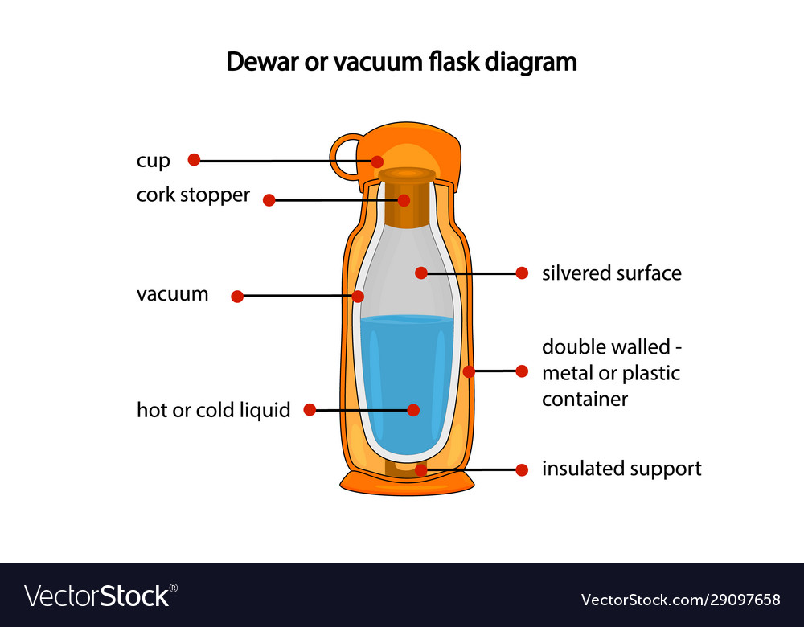

**(Prof. Nagre G.P)**